

Semester 1 Examination, 2019

Question/Answer booklet

ECONOMICS
ATAR Year 12

Student Number: In figures

In words

Time allowed for this paper
Reading time before commencing work: ten minutes
Working time for paper: three hours

Materials required/recommended for this paper

To be provided by the supervisor
This Question/Answer booklet
Multiple-choice answer sheet

To be provided by the candidate
Standard items: pens (blue/black preferred), pencils (included coloured), sharpener,
correction fluid/tape, eraser, ruler, highlighters
Special items: non−programmable calculators approved for use in this examination

Important note to candidates
No other items may be taken into the examination room. It is your responsibility to ensure that you do not have any unauthorised material. If you have any unauthorised material with you, hand it to the supervisor before reading any further.

Structure of this paper

Section | Number of questions available | Number of questions to be answered | Suggested working time  (minutes) | Marks available | Percentage of exam
Section One:  Multiple-choice | 24 | 24 | 30 | 24 | 24
Section Two:  Short Answer | 3 | 3 | 70 | 36 | 36
Section Three:  Extended Answer | 4 | 2 | 80 | 40 | 40
 |  |  |  | Total | 100

Instructions to candidates

1. The rules for the conduct of Western Australian Certificate of Education ATAR course examinations are detailed in the Year 12 Information Handbook 2018. Sitting this examination implies that you agree to abide by these rules.

2. Write your answers in this Question/Answer booklet preferably using a blue/black pen. Do not use erasable or gel pens.

3. Answer the questions according to the following instructions.

Section One: Answer all questions on the separate Multiple-choice answer sheet provided. For each question, shade the box to indicate your answer. Use only a blue or black pen to shade the boxes. If you make a mistake, place a cross through that square, then shade your new answer. Do not erase or use correction fluid/tape. Marks will not be deducted for incorrect answers. No marks will be given if more than one answer is completed for any question.

Sections Two and Three: Write your answers in this Question/Answer booklet.

4. You must be careful to confine your answers to the specific questions asked and to follow any instructions that are specific to a particular question.

5. Supplementary pages for planning/continuing your answers to questions are provided at the end of this Question/Answer booklet. If you use these pages to continue an answer, indicate at the original answer where the answer is continued, ie give the page number.

MARK ALLOCATION/MARKS AWARDED

SECTION | QUESTIONS | MARKS
1. Multiple Choice | Attempt all 24  questions | /24
2. Short Answer  (Data Interpretation) | Answer all 3  questions | 36 marks
 | Qu. 25 | /12
 | Qu. 26 | /12
 | Qu. 27 | /12
3. Extended Answer  (Essay) | Answer only  2 questions | 40 marks
You must write the number  of the essay you attempted  in the spaces opposite. | Qu _______ | /20
 | Qu _______ | /20
TOTAL |  | /100

Teacher’s Comment:

________________________________________________________________________

________________________________________________________________________

________________________________________________________________________

________________________________________________________________________

________________________________________________________________________

Section One: Multiple-choice 24% (24 Marks)

This section has 24 questions. Answer all questions on the separate Multiple-choice answer sheet provided. For each question, shade the box to indicate your answer. Use only a blue or black pen to shade the boxes. If you make a mistake, place a cross through that square, then shade your new answer. Do not erase or use correction fluid/tape. Marks will not be deducted for incorrect answers. No marks will be given if more than one answer is completed for any question.

Suggested working time: 30 minutes.

1. Globalisation is beneficial for firms because it
(a) protects them against foreign competition.
(b) cushions them from the effects of events in other countries.
(c) opens up new market opportunities.
(d) increases the risk and uncertainty of operating in a globalising world economy.

2. Which region accounts for most of the world’s exports?
(a) North America
(b) Europe
(c) Asia
(d) Middle East

3. Two important indicators of a country’s international competitiveness are
(a) its trade intensity ratio and its real GDP per capita.
(b) the size of its trade balance and its inflation rate.
(c) its real unit labour costs and the value of its exchange rate.
(d) its terms of trade index and its relative productivity.

4. The value of trade between countries A and B increases while the value of trade between countries A and C decreases. All other things being equal, this most likely occurred because country A
(a) implemented a free trade agreement with country B.
(b) implemented a free trade agreement with country C.
(c) raised import tariffs on both country B and country C.
(d) reduced import tariffs on both country B and country C.

5. All of the following are sources of comparative advantage except
(a) climate and natural resources.
(b) relative abundance of labor and capital.
(c) technology.
(d) a strong foreign currency exchange rate.

6. The table shows the annual production per worker per year in three countries. There are no trade barriers, no transport costs and the countries specialise on the basis of opportunity cost.
Product (tonnes) | Southland | Westland | Eastland
Apples | 100 | 80 | 12
Wheat | 80 | 70 | 16
Rice | 60 | 60 | 8

Which country will export which product?
 | Southland | Westland | Eastland
(a) | Rice | Apples | Wheat
(b) | Apples | Rice | Wheat
(c) | Wheat | Rice | Apples
(d) | Apples | Wheat | Rice

7. The net effect of regional trade agreements has been
(a) an increase in the total amount of trade in the world.
(b) a decrease in the total amount of trade in the world.
(c) no change in the total amount of trade in the world.
(d) either an increase or decrease in the amount of trade in the world, depending on where trade takes place.

8. If supporters of restrictions on imports argue that protection is needed to preserve a strategic industry; which of the following is being used?
(a) Save domestic jobs argument.
(b) National security argument.
(c) Dumping argument.
(d) Infant-industry argument.

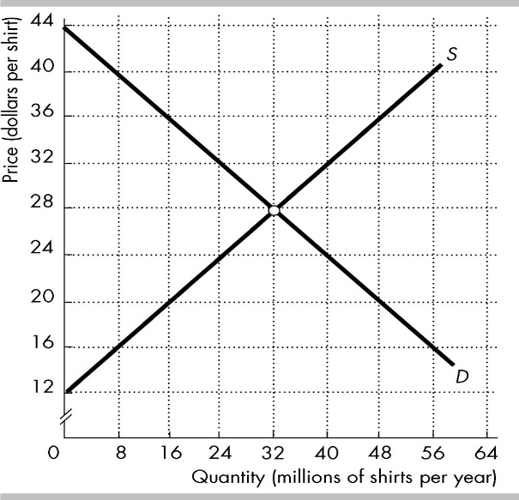
9. The figure shows the market for shirts in an economy, where D is the domestic demand curve and S is the domestic supply curve. The world price is $20 per shirt. The country imposes a tariff on imported shirts of $4 per shirt.
The tariff ________ imports of shirts by ________ million shirts per year.
(a) decreases; 16
(b) decreases; 8
(c) increases; 16
(d) increases; 8

10. What are Australia's two main imports?
(a) personal travel and telecom equipment
(b) education services and computers
(c) passenger motor vehicles and refined petroleum
(d) personal travel and passenger motor vehicles

Current Account | $ million
Exports | 5800
Imports | 5500
Net Services | –800
Net Income | –400
11. This question relates to the table opposite.
The balance on the capital and financial account is
(a) $400 million.
(b) $500 million.
(c) $900 million.
(d) -$900 million.

12. Fluctuations in the current account balance are mainly the result of fluctuations in
(a) net interest.
(b) foreign reserves.
(c) net income.
(d) net exports.

13. Which of the following could lead to an increase in the cyclical component of Australia’s current account deficit?
(a) An increase in net foreign liabilities
(b) An increase in the investment-savings gap
(c) A decrease in exports due to a weakening global economy
(d) An increase in exports resulting from an improvement in the terms of trade

14. Suppose BHP Billiton purchases a gold mine in Canada. In Australia’s balance of payments, this purchase would be entered into the___________ account while the dividends from the mine would be entered into the __________ account
(a) financial; current
(b) current; financial
(c) financial; trade
(d) capital; income

15. Which of the following would be likely to occur if the Australian dollar depreciates significantly against the currencies of its trading partners?
(a) A fall in the quantity of goods exported from Australia
(b) An increase in imported inflation into Australia
(c) An increase in the quantity of goods imported into Australia
(d) A fall in the cost of travelling overseas from Australia

16. You are traveling in Germany and are thinking about buying a new digital camera. You have decided you would be willing to pay $125 for a new camera, but cameras in Germany are all priced in euros. If the camera you are looking at costs 115 euros, under which of the following exchange rates would you be willing to purchase the camera?
(a) 0.76 euros per dollar
(b) 0.88 euros per dollar
(c) 0.93 euros per dollar
(d) You would purchase the new camera at any of the above exchange rates.

17. Refer to the table below:
Year | Import price index | Export price index
1 | 100 | 100
2 | 104 | 117

The change in the terms of trade from Year 1 to Year 2 most likely means that, for this country
(a) the exchange rate will fall.
(b) the current account deficit will rise.
(c) the value of exports is greater than the value of imports.
(d) more imports can be bought with a given volume of exports.

18. Which of the following best explains the changes in the TOT and the TWI from Year 1 to Year 2?
Year | Terms of trade (TOT) | Trade weighted index (TWI)
1 | 100 | 50
2 | 110 | 60

(a) There is an increase in global demand for the goods this economy exports and imports.
(b) The economy’s central bank increases interest rates relative to global interest rates.
(c) Global demand for the goods this economy imports has increased relative to global demand for the goods this economy exports.
(d) Global demand for the goods this economy exports has increased relative to global demand for the goods this economy imports.

19. ________________ investment is the flow of funding provided by an investor to establish or acquire a foreign company or to expand or finance an existing foreign company that the investor owns or controls.
(a) International portfolio
(b) International capital
(c) Foreign direct
(d) Foreign indirect

20. In the short term, a decrease of foreign investment into Australia will
(a) increase the current account deficit and depreciate the dollar.
(b) decrease the financial account balance and depreciate the dollar.
(c) appreciate the dollar and increase imports.
(d) increase the current account balance by boosting imports.

21. Currency traders expect the value of the Australian dollar to fall. What effect will this have on the demand for and the supply of Australian dollars in the foreign exchange market?
(a) Demand for dollars will increase, and supply of dollars will decrease.
(b) Demand for dollars will increase, and supply of dollars will increase.
(c) Demand for dollars will decrease, and supply of dollars will decrease.
(d) Demand for dollars will decrease, and supply of dollars will increase.

22. There is a significant increase in official interest rates in the United States of America (US). All other things being equal, which of the following would be true?
(a) There would be increased supply of $AUD and the $AUD would depreciate.
(b) There would be decreased supply of $AUD and the $AUD would appreciate.
(c) There would be increased demand for $AUD and the $AUD would depreciate.
(d) There would be decreased demand for $AUD and the $AUD would appreciate.

23. Which of the following would help to reduce Australia's foreign debt?
(a) An increase in the rate of domestic saving
(b) An increase in net foreign liabilities
(c) An increase in the level of foreign investment into the Australian economy
(d) An increase in the current account deficit

24. There is a rise in the exchange rate of the AUD$. Which would cause the greatest increase in Australia’s current account deficit?
(a) A rise in the terms of trade
(b) A high price elasticity of demand for imports
(c) A low price elasticity of demand for exports
(d) A low rate of domestic inflation

End of Section One
Section Two: Short Answer (Data Interpretation) 36% (36 Marks)

This section has three (3) questions. Answer all questions. Write your answers in the spaces provided.

Additional working space pages at the end of this Question/Answer booklet are for planning or continuing an answer. If you use these pages, indicate at the original answer, the page number it is planned/continued on and write the question number being planned/continued on the additional working space page.

Suggested working time: 70 minutes.

Question 25 (12 marks)

Australia records bumper trade surplus in 2018
Australia recorded a $22.2 billion trade surplus in 2018, which was the highest ever for a calendar year. Australia’s two-way trade in goods and services also hit a record high of $854 billion in 2018. Increased resource exports along with rural goods helped contribute to Australia’s strong 2018 result, while natural gas exports grew by 70 percent to become Australia’s third largest export. Our services industries, including education and tourism, also continue to enjoy strong growth with services exports growing by 9 per cent. China remained Australia's top trading partner, a position it has held since 2009.
The Minister for Trade said trade continued to play a critical role in Australia’s continued economic success having contributed over one-quarter of Australia’s economic growth over the past five years. Over the past five years, total trade covered by free trade agreements has increased from 26 per cent to around 70 per cent, providing more opportunities for Australian exporters to sell their quality produce and goods to the world. Source: DFAT media release 5 February 2019

(a) i. What was unusual about Australia’s trade balance in 2018? (1 mark)

____________________________________________________________________________
____________________________________________________________________________
____________________________________________________________________________

(a) ii. Define ‘two-way’ trade. (1 mark)
____________________________________________________________________________
____________________________________________________________________________
____________________________________________________________________________

(a) iii. What are Australia’s two (2) largest exports? (1 mark)
____________________________________________________________________________
____________________________________________________________________________
____________________________________________________________________________
(b) Explain how the change in Australia’s trade balance in 2018 would have affected both the current account and the financial account in the balance of payments.
(3 marks)
____________________________________________________________________________
____________________________________________________________________________
____________________________________________________________________________
____________________________________________________________________________
____________________________________________________________________________
____________________________________________________________________________
____________________________________________________________________________
____________________________________________________________________________
____________________________________________________________________________
____________________________________________________________________________

(c) Explain how each of the following factors may have contributed to Australia’s record trade surplus in 2018:
i. the exchange rate (2 marks)
ii. the terms of trade (2 marks)
iii. free trade agreements (2 marks)

i.___________________________________________________________________________
____________________________________________________________________________
____________________________________________________________________________
____________________________________________________________________________
____________________________________________________________________________
____________________________________________________________________________
____________________________________________________________________________

ii.__________________________________________________________________________
____________________________________________________________________________
____________________________________________________________________________
____________________________________________________________________________
____________________________________________________________________________
____________________________________________________________________________
____________________________________________________________________________

iii.__________________________________________________________________________
____________________________________________________________________________
____________________________________________________________________________
____________________________________________________________________________
____________________________________________________________________________
____________________________________________________________________________
____________________________________________________________________________

Question 26 (12 marks)

Global economic indicators
Source: World Bank

(a) Identify two separate items of evidence that show the pace of globalisation
slowed during 2018. (2 marks)
____________________________________________________________________________
____________________________________________________________________________
____________________________________________________________________________
____________________________________________________________________________
____________________________________________________________________________
____________________________________________________________________________
____________________________________________________________________________

(b) What is a trade war? What evidence suggests that the US and China were engaged in a trade war in 2018? (3 marks)
____________________________________________________________________________
____________________________________________________________________________
____________________________________________________________________________
____________________________________________________________________________
____________________________________________________________________________
____________________________________________________________________________
____________________________________________________________________________
____________________________________________________________________________
____________________________________________________________________________
____________________________________________________________________________

(c) Provide three reasons why the US government would initiate a trade war with China. (3 marks)
____________________________________________________________________________
____________________________________________________________________________
____________________________________________________________________________
____________________________________________________________________________
____________________________________________________________________________
____________________________________________________________________________
____________________________________________________________________________
____________________________________________________________________________
____________________________________________________________________________
____________________________________________________________________________
____________________________________________________________________________

(d) Explain how a tariff harms both the importing country and the exporting country. (4 marks)
____________________________________________________________________________
____________________________________________________________________________
____________________________________________________________________________
____________________________________________________________________________
____________________________________________________________________________
____________________________________________________________________________
____________________________________________________________________________
____________________________________________________________________________
____________________________________________________________________________
____________________________________________________________________________
____________________________________________________________________________
____________________________________________________________________________
____________________________________________________________________________
____________________________________________________________________________

Question 27 (12 marks)

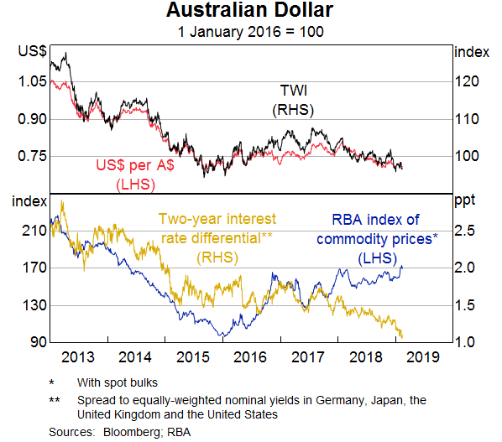
Source: RBA

(a) Define the following terms: (2 marks)
i. TWI: ______________________________________________________________________
____________________________________________________________________________
____________________________________________________________________________
____________________________________________________________________________
____________________________________________________________________________
ii. Australia’s interest rate differential: ___________________________________________
____________________________________________________________________________
____________________________________________________________________________
____________________________________________________________________________
____________________________________________________________________________

(b) In which period shown on the graph was the Australian dollar at its highest

value? State the value against the $US and the TWI and provide ONE

reason for its high value. (3 marks)
____________________________________________________________________________
____________________________________________________________________________
____________________________________________________________________________
____________________________________________________________________________
____________________________________________________________________________
____________________________________________________________________________
____________________________________________________________________________
____________________________________________________________________________
____________________________________________________________________________

(c) Using evidence from the graph, explain the relationship between changes in commodity prices and the Australian dollar. (4 marks)
____________________________________________________________________________
____________________________________________________________________________
____________________________________________________________________________
____________________________________________________________________________
____________________________________________________________________________
____________________________________________________________________________
____________________________________________________________________________
____________________________________________________________________________
____________________________________________________________________________
____________________________________________________________________________
____________________________________________________________________________
____________________________________________________________________________
____________________________________________________________________________

(d) Which factor was largely responsible for the change in the value of the Australian dollar during 2018? Explain your answer. (3 marks)
____________________________________________________________________________
____________________________________________________________________________
____________________________________________________________________________
____________________________________________________________________________
____________________________________________________________________________
____________________________________________________________________________
____________________________________________________________________________
____________________________________________________________________________
____________________________________________________________________________
____________________________________________________________________________
____________________________________________________________________________
____________________________________________________________________________

End of Section Two

Section Three: Extended Answer (Essay) 40% (40 Marks)

This section contains four (4) questions. Answer two (2) questions. Write your answers in the lined pages provided and number your answers clearly.

Additional working space pages at the end of this Question/Answer booklet are for planning or continuing an answer. If you use these pages, indicate at the original answer, the page number it is planned/continued on and write the question number being planned/continued on the additional working space page.

Suggested working time: 80 minutes.

Question 28 (20 marks)

(a) Outline the role of the World Trade Organisation (WTO) in facilitating globalisation and evaluate the economic effects of globalisation. (12 marks)

(b) Discuss the ways in which the Australian economy is dependent on the global economy. (8 marks)
_____________________________________________________________________

Question 29 (20 marks)

(a) Demonstrate the theory of comparative advantage using the production possibility frontier model and the concept of opportunity cost. (12 marks)

(b) Evaluate the efficiency of a subsidy as a form of protection to an import competing industry. (8 marks)
_____________________________________________________________________

Question 30 (20 marks)

(a) Using examples, describe the main components of Australia’s current account. (8 marks)

(b) Explain the effects of each of the following on Australia’s current account deficit:
i. a decrease in Australia’s economic growth
ii. an increase in foreign investment
iii. an increase in the TWI (12 marks)
____________________________________________________________________

Question 31 (20 marks)

(a) Distinguish between Australia’s foreign assets and foreign liabilities and outline the recent trends in Australia’s net foreign liabilities. (12 marks)

(b) Australia’s net foreign debt has increased to around $1,100bn. Is this a cause for concern? Give reasons to support your answer. (8 marks)

_____________________________________________________________________

End of questions
Question number:

Question number:

Question number:

Question number:

Question number:

Question number:

Question number:

Question number:

Additional Working Space:

Additional Working Space:

Additional Working Space:

Additional Working Space:

Additional Working Space:

Additional Working Space:

